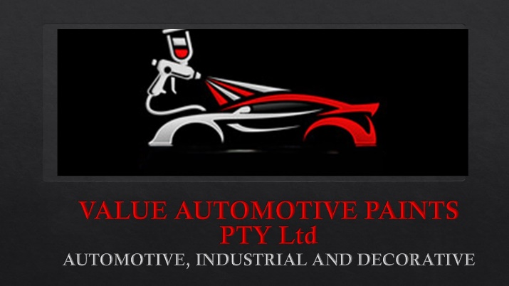
VALUE AUTOMOTIVE PAINTS
LIFETIME WARRANTY
Value.automotive2@gmail.com
www.value-automotive-paints.com
060 975 2332
060 975 2335

Value Automotive Paints Refinishes.

- Warranties:
  - Stirflow paints Pty Ltd (Hereinafter referred to as the Manufacturer), warrants in favour of Value Automotive Paints PTY Ltd (Hereinafter referred to as the Customer) that, subject to the terms and conditions set out below and to the exclusions contained in in clause 2, and further subject to the customer complying with its obligations contained in clause 3:
- The Paint products supplied in the VALUE AUTOMOTIVE PAINTS brand, which is manufactured by the manufacturer, when correctly applied, will not.
- Loose gloss or change colour to any degree greater than the manufacturers specifications for the said coating, or
- Crack, Glaze, peel, or loft.
  - When claims is made pursuant to clause 1.1 which claim is brough without time limit ( Lifetime warranty) in writing to the attention of the manufacturer in which is thereafter in the sole and absolute discretion of the manufacturer- verified as operative in terms of this warranty, then in that event the manufacturer shall provide to the customer the specification for repair and after the customer has caused the repair to be carried out as specified, the manufacturer shall replace the materials used by the customer in repairing the vehicle.
  - The Manufacturer may carry out any necessary tests (including destructive test) on the paint work in respect of which a claim is made under clause 1.1.

- EXCLUSIONS

The liability of the manufacturer in respect of the paint products in the VALUE AUTOMOTIVE PAINTS RANGE shall be limited to its liability under clause 1, with limiting the generality of the afore going and save as provided herein the customer will have no other claim of whatsoever nature against the manufacturer and accordingly the manufacturer shall not be liable for any loss or damage whatsoever suffered by the customer or any third party including any loss of profit or direct, special or consequential damages whatsoever.
  - The warranties contained in clause 1 shall not apply to any defect referred to, which is not directly attributed to the paint manufactured by manufacturer pertaining to the specific paint system which has been in the circumstances correctly selected for application, including without limitation:
- Fractures, Chips, abrasions, or similar damages.
- Any damage resulting from direct contact with deleterious substances or from the presence of deleterious substances in the atmosphere. (e.g., Hail)
- Deliberate Damages
- Sharp edge corrosion
- Damage caused by rust or rust under creep.
- Damage wholly or partially caused by the original paint finish.
- Complaints relating to the colour or colour matching of the refinish paint as applied by the customer or any other third party. (other than loss of gloss or change colour)
- Damage caused by dirt being trapped in the topcoat or undercoats.
- Complaints or damage relating to the application of paint products or support materials in the VALUE AUTOMOTIVE PAINTS system which upon the removal of packaging are deemed at the instance of the manufacturer, not to have been manufacturer by it.
- Any other damage occasioned by misuse or abuse.
  - The warranties contained in clause 1 shall not apply if:
- Products other than those manufactured by the manufacturer including the support materials associated with these products were used.
- The customer or any third party failed to strictly follow the procedures specified in all technical data sheets applicable to the products in use (as may be amended from time to time) and / or said customer and /or third party was negligent in any way.
- The spray painter employed by the customer, or any third party was at time of application of the material in question not formally qualified.

- OBLIGATIONS
THE CUSTOMER shall insure that it or any third party –
- Strictly follow the procedure specified in all technical data sheet applicable to the products in use (As amended from time to time)
- Ensure that painting is carried out by a formally qualified spray painter.
- Ensure that the manufacturer is able to carry out any necessary tests on the paint work in respect of which a claim is made under clause 1.
- Not apply paint products or support materials in otherwise correctly selected paint system that are not fit for use.

- TERMINATION
The Manufacturer may at any time terminate this agreement. Follow termination of this agreement, the manufacturer may, in its absolute discretion, rectify any claim made in respect of work performed using the paint products forming the subject matter of this warranty during the period thereof but shall not be obliged to do so.

- UNDERTAKING
Save as otherwise provided herein, the customer hereby indemnifies and holds the manufacturer harmless against any claims which may be made against it by any third party in respect of any act or omission on the part of the customer and / or the manufacturer and / or its servants, agents or permitted sub-contractors.

- GENERAL
This document constitutes the sole record of the agreement between the parties, as regards the import hereof. Neither party shall be bound by any representation, warranty, promises nor the like not recorded herein. No addition to or variation or agreed cancellation of this agreement shall be of any force or effect unless in writing and signed by or on behalf of the parties.

THUS SIGNED ON BEHALF OF VALUE AUTOMOTIVE PAINTS IN 2018

________________________________(DIRECTOR)

