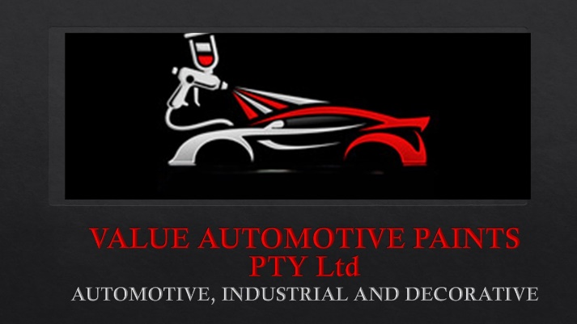
VALUE AUTOMOTIVE PAINTS
INTRODUCTION
Value.automotive2@gmail.com
www.value-automotive-paints.com
060 975 2332
060 975 2335

VALUE AUTOMOTIVE PAINTS PTY Ltd.
INTRODUCTION

Thank You for the opportunity to introduce our Company to you.

About us
Value Automotive Paints is a Automotive, Industrial paint Supplier based in Kempton Park, Gauteng, South Africa, Value Automotive Paints was established in 2017. We are specializing in automotive, industrial, and decorative paint solutions. With years of experience, we pride ourselves on delivering outstanding service and quality finishes at affordable prices. Our team of skilled professionals is dedicated to meeting your specific needs, ensuring excellence in every project. Whether you're revamping your vehicle, protecting industrial machinery, or elevating your space with decorative paints, we're here to
Brands that we offer at Value Automotive Paints, Kindly contact us for a full list.

- Plascon Automotive
- Plascon Industrial
- HB
- Luxor
- Transline
- MILITARY PAINT
- Smirdex
- Mirka
- Sunmight Abrasives
- Bosch
- Duxone
- Plascon Decorative
- Stanley
- Jonsson Safety
- Academy Brushware
- Soudal
- Torkcraft
- Automax
- Farecla
- Glissen
- Gluedevil

Our Products are simply well known in the industry, we also Manufacture our OWN BRAND of paint and Solvents, which is manufactured by a well-known Factory is Edenvale, they have been manufacturing paint for the last 50 years, They are also known for the Manufacturing of Chariot, Gun gloss etc.
Should you wish to receive more information, or would like for us to become your trustworthy supplier, do not hesitate to contact us,
We can also provide if wanted references of our Paint and Services.

